CICS字段说明
大连理工大学 姚晗 杨发雪 龙梦颖

1 全局变量 1
2 TClassItem 4
3 TransactionManagerItem 5
4 TransactionManagerReport 6
5 DispatcherItem 7
6 DispatcherReport 10
7 EnqueueItem 11
8 EnqueueReport 13
9 StorageManagerItem 14
10 StorageManagerReport 21
11 LogManagerItem 22
12 LogManagerReport 24
13 DB2ENTRYItem 25
14 DB2CONNItem 29
15 DB2Report 31
16 DumpItem 32
17 DumpReport 33
18 TSQItem 34
19 TSQReport 37
20 TDQItem 38
21 TDQReport 40
22 ConnectionItem 41
23 ConnectionReport 42
24 IntervalItem 43
25 IntervalItemListByInterval 45
26 IntervalReport 47

1 全局变量
def StringToInt(input_string) 将字符串转化成数字，去除，KMG单位等符号
def ConvertGMK(input_string) 将数字转化成KMG单位
def copyFiles(sourceDir, targetDir) 复制sourceDir文件到targetDir
def ApplidMatch(ApplidPattern, currentApplid) 识别APPLID符合正则表达式

global CICSVERSION
global TCLASSNAME
global DSARATIOTHRES
global EDSARATIOTHRES
global QRDISPRATIOTHRES
global ENQIMMESUCCESSTHRESHOLD
global APPLIDPATTERN
global STATISTICS_DATE
global PEAK_INTERVAL
global TMFlag
global DSFlag
global LGFlag
global DBFlag
global NQFlag
global TSQFlag
global TDQFlag
global SMFlag
global CONFlag
global DUFlag

TCLASSNAME = "*TOTALS*" #Change the TClass name per your request, by default TOTALS is used
ENQNAME = "*TOTALS*" #Change the ENQ name per your request, by default TOTALS is used
CICSVERSION = "6.8.0"
DSARATIOTHRES = 90.00
EDSARATIOTHRES = 90.00
QRDISPRATIOTHRES = 50.00
ENQIMMESUCCESSTHRESHOLD = 90.00
STATISTICS_DATE = ''
PEAK_INTERVAL = ''
TMFlag = 0
TCFlag = 0
DSFlag = 0
LGFlag = 0
DBFlag = 0
NQFlag = 0
TSQFlag = 0
TDQFlag = 0
SMFlag = 0
CONFlag = 0
DUFlag = 0

TCLASSNAME = config["TClassName"]
ENQNAME = config["ENQName"]
DSARATIOTHRES = float(config["DSARatioThreshold"])
EDSARATIOTHRES = float(config["EDSARatioThreshold"])
QRDISPRATIOTHRES = float(config["QRDispRatioThreshold"])
ENQIMMESUCCESSTHRESHOLD = float(config["ENQImmeSuccessThreshold"])
APPLIDPATTERN = config["ApplidPattern"]

IntItem = IntervalItem()
IntRep = IntervalReport()
IntRep.AppendItem(IntItem)
TMRep = TransactionManagerReport()
DSRep = DispatcherReport()
NQRep = EnqueueReport()
SMRep = StorageManagerReport()
LGRep = LogManagerReport()
DBRep = DB2Report()
DURep = DumpReport()
TSQRep = TSQReport()
TDQRep = TDQReport()
CONRep = ConnectionReport()

2 TClassItem
__CSVString = '' #CSV string
Applid = '' #CICS Application ID
Date = '' #Data collection data
ResTime = '' #Last rest time
ColTime = '' #Data collection time
TClassName = '' #Transaction Class name
TClassDef = 0 #Transactions in this class
MaxAct = 0 # maximum number of transactions
PrgThrs = 0 #Purge threshold
Attaches = 0 #attach requests
AcptImm = 0 #transactions which are accepted immediately
PrgImm = 0 #transactions which are purged immediately
Queued = 0 #transactions which are queued
PrgQd = 0 #Purged while queuing
QuedTime ='' #Queued time
PckAct = 0 #Peak Active
PckQued = 0 #Peak Queued
MaxActTimes = 0 #MXT Active times
PrgThrsTimes = 0 #times at purge threshold

def TClassItemCSV(self)

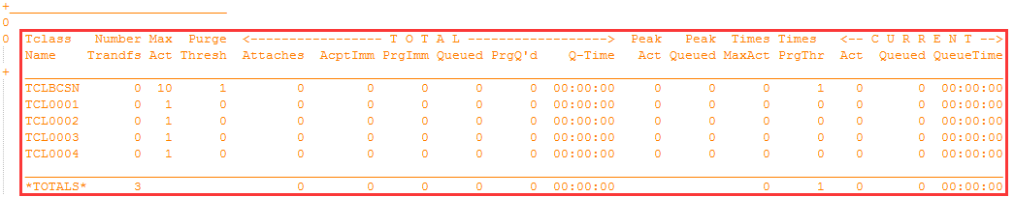

获得every, Totals：TClassName、TClassDef、MaxAct、PrgThrs、Attaches、AcptImm、PrgImm、Queued、PrgQd、QuedTime、PckAct、PckQued、MaxActTimes、PrgThrsTimes

3 TransactionManagerItem
__CSVString = '' #CSV string
Applid = '' #CICS Application ID
Date = '' #Data collection data
ResTime = '' #Last rest time
ColTime = '' #Data collection time
TotTran = 0 #Total transaction numer (User + System)
MXT = 0 #MXT setting
MXTTimeRch = 0 #MXT reach time
PkQued = 0 #Peak queued task number
PkActv = 0 #Peak active task number
TotlActUsr = 0 #Total active user transaction number
TotlDly = 0 #Total Delayed transactin number
MXTRatio = 0.0 #Peak active/MXT
IntervalValue = 0.0 #Interval in seconds
TClassItemList = list() #TClass list

global TCLASSNAME

def __init__(self)
def AppendTClassItem(self,TCItem)
def PickedTClassItem(self)
def TMItemCSV(self)
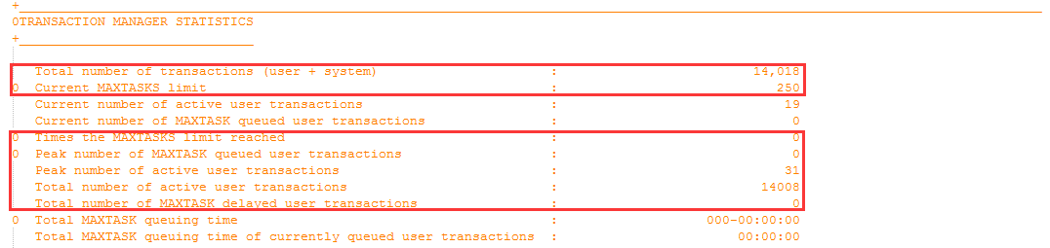
获得 TolTran、MXT、MXTimeRch、PkQued、PkActv、TotlActUsr、TotlDly
MXTRatio = PkActv/MXT

4 TransactionManagerReport
__Title_TM = "Applid,Date,ResTime,ColTime,TotTran,MXT,MXTTimeRch,PkQued,PkActv,TotlActUsr,TotlDly,MXTRatio%"
__Title_TC = "Applid,Date,ResTime,ColTime,TClassName,Trandfs,NaxAct,PrgThrs,Attaches,AcptImm,PrgImm,Queued,PrgQd,QuedTime,PckAct,PckQued,MaxActTimes,PrgThrsTimes"

TMItemList = list() #Transaction item list

def __init__(self)
def AppendItem(self, TMItem)
def PrintInCSV(self)
def DumpToFile(self)

5 DispatcherItem
__CSVString = '' #CSV string
Applid = '' #CICS Application ID
Date = '' #Data collection data
ResTime = '' #Last rest time
ColTime = '' #Data collection time
ASCPU = '' #Address space CPU time
ASSRB = '' #Address space SRB time
ICV = 0 #ICV setting
ICVR = 0 #ICVR setting

QRDsp = '00:00:00' #QR dispatch time
QRCPU = '00:00:00' #QR CPU time
QRCPUUtilRatio = 0.0 #QR CPU/Interval
QRDispUtilRatio = 0.0 #QR Disp/Interval
QRDispRatio = 0.0 #QR CPU/dispatch

L8Dsp = '00:00:00' #L8 dispatch time
L8CPU = '00:00:00' #L8 CPU time
L8CPUUtilRatio = 0.0 #L8 CPU/Interval
L8DispUtilRatio = 0.0 #L8 Disp/Interval
L8DispRatio = 0.0 #L8 CPU/dispatch

ASCPUUtilRatio = 0.0 #Address space TCB CPU/Interval
SRBCPUUtilRatio = 0.0 #Address space SRB CPU/Interval
CPUPerUsrTran = 0.0 #CPU time (TCB+SRB) /User transaction
PkOpTCB = 0 #Peak open TCB usage
MAXOpTCB = 0 #Max open TCB usage
OpTCBRatio = 0 #Peak Open TCB/MAXOPENTCB
ASCPUV = 0.0 #Address space CPU in seconds
ASSRB = 0.0 #Address space SRC in seconds
QRDspQueuePk = 0 #Peak QR dispatchable queue length
QRDspQueueAvg = 0.00 #Average QR dispatchable queue length

def DispatcherItemCSV(self)
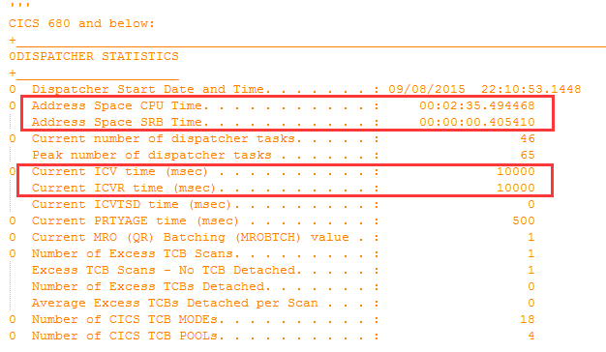
获得：ASCPU、ASSRB、ICV、ICVR

ASCPUUtilRatio = ASCPUV/IntervalV SRBCPUUtilRatio = ASSRBV/IntervalV

TCBMODENUM

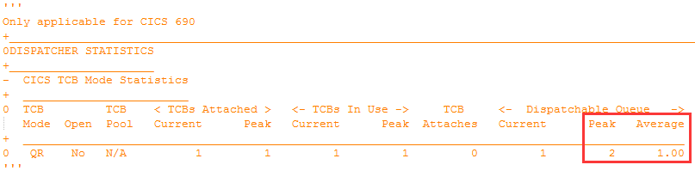
获得：QRDspQueuePk、QRDspQueueAvg

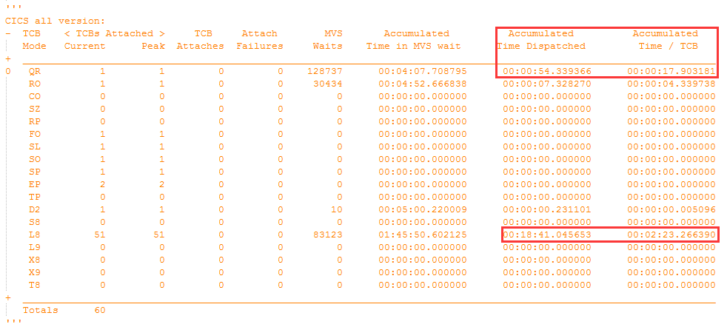
获得：CQRDisp、CQRCPU、CL8Disp、CL8CPU
QRCPUUtilRatio = CQRCPUV/CIntervalV
QRDispUtilRatio = CQRCPUV/CQRDispV
QRDispRadio = CQRDispV/CIntervalV

CL8UtilRatio = CL8CPUV/CIntervalV
CL8DispUtilRatio = CL8CPUV/CL8DispV
CL8DispRatio = CL8DispV/CIntervalV

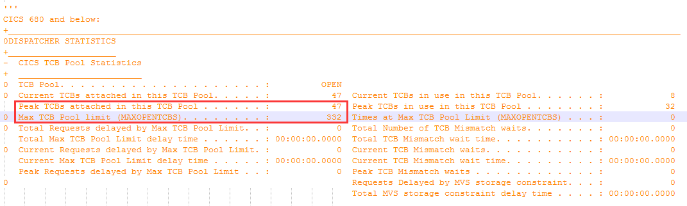
获得：PkOpTCB、MAXOpTCB
opTCBRatio = CPkOpTCB/MAXOpTCB

6 DispatcherReport
__Title = "Applid,Date,ResTime,ColTime,ASCPU,ASSRB,ICV,ICVR,QRCPU,QRDsp,QRCPUUtilRatio%,QRDispUtilRatio%,QRDispRatio%,"+ \
"L8CPU,L8Dsp,L8CPUUtilRatio%,L8DispUtilRatio%,L8DispRatio%,ASTCBUtilRatio%,ASSRBCPUUtilRatio%,CPUPerUsrTran,PkOpTCB,MAXOpTCB,OpTCBRatio%"

global CICSVERSION

DSItemList = list() #Dispatcher item list
def __init__(self)
def AppendItem(self, DSItem)
def PrintInCSV(self)
def DumpToFile(self)

7 EnqueueItem
__CSVString = ''
Applid = '' #CICS Application ID
Date = '' #Data collection data
ResTime = '' #Last rest time
ColTime = '' #Data collection time
ENQPoolName = '' #Selected ENQ pool ID
ENQIssd = 0 #ENQs Issued
ENQWtd = 0 #ENQs Waited
ENQWTT = '' #Enqueue Waiting time
ENQSysWtd = 0 #Sysplex Waited
ENQSysWtT = '' #Sysplex Waiting time
ENQRtnd = 0 #ENQs Retained
ENQRtnT = '' #Enqueue retention time
ImmRejEqBsy = 0 #Immediately rejected ENQBUSY
ImmRejEqRtn = 0 #Immediately rejected due to RETAINED
WtRejRtn = 0 #Waiting requests that were rejected due to the enqueue moving into a retained state
WtRejOp = 0 #Waiting requests that were rejected due to the operator purging the waiting transaction
WtRejTo = 0 #Waiting requests that were rejected due to the timeout value being exceeded
ENQBusyRatio = 0.0 #ENQ Busy/ENQIssd
ENQWttRatio= 0.00 #ENQ Waited/ENQIssd
ENQRetRatio= 0.00 #ENQ Retained/ENQIssd
ENQImmRetRatio = 0.00 #ENQ Imme RETAINED/ENQIssd
ENQImmSuccessRatio = 0.00#Endqueue Immediate success

def EnqueueItemCSV(self):

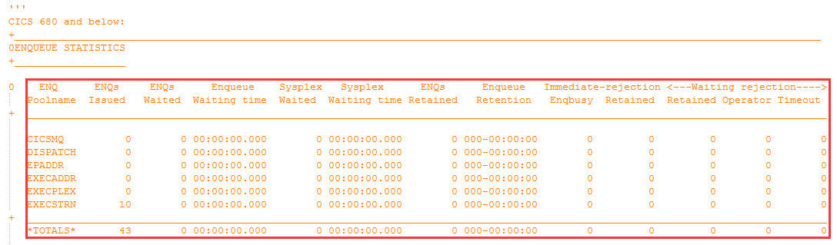
获得：ENQIssd、ENQWtd、ENQWTT、ENQSysWtd、ENQSysWtT、ENQRtnd、ENQRtnT、ImmRejEqBsy、ImmRejEqRtn、WtRejRtn、WtRejOp、WtRejTo

ENQBusyRatio = ImmRejEqBsy/ENQIssd
ENQWttRatio = ENQWtd/ENQIssd
ENQRetRatio = ENQRtnd/ENQIssd
ENQImmRetRatio = ImmRejEqRtn/ENQIssd
ENQImmSuccessRatio = 100-ENQBusyRatio-ENQWttRatio-ENQRetRatio-ENQImmRetRatio

8 EnqueueReport
__Title = "Applid,Date,ResTime,ColTime,ENQPoolName,ENQIssd,ENQWtd,ENQWTT,ENQSysWtd,ENQSysWtT,ENQRtnd,ENQRtnT,ImmRejEqBsy,ImmRejEqRtn,WtRejRtn,WtRejOp,WtRejTo,ENQBusyRatio%,ENQWttRatio%,ENQRetRatio%,ENQImmRetRatio%,ENQImmSuccessRatio%"
NQItemList = list()
def __init__(self)
def AppendItem(self, NQItem)
def PrintInCSV(self)
def DumpToFile(self)

9 StorageManagerItem
__CSVString = ''
Applid = '' #CICS Application ID
Date = '' #Data collection data
ResTime = '' #Last rest time
ColTime = '' #Data collection time
STGPROT = '' #Storage Protection
TRANISO = '' #Transaction Isolation
REENTPG = '' #Write protection for reentrant programs
DSALIM = 0 #Current DSA Limit
PeakDSA = 0 #Peak DSA usage
EDSALIM = 0 #Current EDSA Limit
PeakEDSA = 0 #Peak EDSA usage
MEMLIMIT = '' #z/OS MEMLIMIT
CDSASize = 0 #Peak CDSA usage
UDSASize = 0 #Peak UDSA usage
SDSASize = 0 #Peak SDSA usage
RDSASize = 0 #Peak RDSA usage
ECDSASize = 0 #Peak ECDSA usage
EUDSASize = 0 #Peak EUDSA usage
ESDSASize = 0 #Peak ESDSA usage
ERDSASize = 0 #Peak ERDSA usage
ETDSASize = 0 #Peak ETDSA usage

CDSAHWM = 0 #Peak - Lowest Free
UDSAHWM = 0 #Peak - Lowest Free
SDSAHWM = 0 #Peak - Lowest Free
RDSAHWM = 0 #Peak - Lowest Free
DSAHWMTotal = 0 #Total DSA HWM

DSASOSTms = 0 #SOS times
DSASTGVIOLTms = 0 #Storage Violation times

ECDSAHWM = 0 #Peak - Lowest Free
EUDSAHWM = 0 #Peak - Lowest Free
ESDSAHWM = 0 #Peak - Lowest Free
ERDSAHWM = 0 #Peak - Lowest Free
ETDSAHWM = 0 #Peak - Lowest Free
EDSAHWMTotal = 0 #Total EDSA HWM
EDSASOSTms = 0 #SOS times
EDSASTGVIOLTms = 0 #Storage Violation times

DSARatio = 0.0 #Peak DSA/DSALIM
EDSARatio = 0.0 #Peak EDSA/EDSALIM
CDSARatio = 0.0 #Percentage of CDSA
UDSARatio = 0.0 #Percentage of UDSA
SDSARatio = 0.0 #Percentage of SDSA
RDSARatio = 0.0 #Percentage of RDSA
ECDSARatio = 0.0 #Percentage of ECDSA
EUDSARatio = 0.0 #Percentage of EUDSA
ESDSARatio = 0.0 #Percentage of ESDSA
ERDSARatio = 0.0 #Percentage of ERDSA
ETDSARatio = 0.0 #Percentage of ETDSA
DSAHWMRatio = 0.0 #DSA HWM/DSALIM
EDSAHWMRatio = 0.0 #EDSA HWM/EDSALIM

CDSAFSTG = 0 #CDSA Free storage
UDSAFSTG = 0 #UDSA Free storage
SDSAFSTG = 0 #SDSA Free storage
RDSAFSTG = 0 #RDSA Free storage

ECDSAFSTG = 0 #ECDSA Free storage
EUDSAFSTG = 0 #EUDSA Free storage
ESDSAFSTG = 0 #ESDSA Free storage
ERDSAFSTG = 0 #ERDSA Free storage

CDSALFA = 0 #CDSA Largest Free Area
UDSALFA = 0 #USDA Largest Free Area
SDSALFA = 0 #SDSA Largest Free Area
RDSALFA = 0 #RDSA Largest Free Area

ECDSALFA = 0 #ECDSA Largest Free Area
EUDSALFA = 0 #EUDSA Largest Free Area
ESDSALFA = 0 #ESDSA Largest Free Area
ERDSALFA = 0 #ERDSA Largest Free Area

CDSAFragRatio = 0.0 #CDSALFA/CDSAFSTG
UDSAFragRatio = 0.0 #UDSALFA/UDSAFSTG
SDSAFragRatio = 0.0 #SDSALFA/SDSAFSTG
RDSAFragRatio = 0.0 #RDSALFA/RDSAFSTG

ECDSAFragRatio = 0.0 #ECDSALFA/ECDSAFSTG
EUDSAFragRatio = 0.0 #EUDSALFA/EUDSAFSTG
ESDSAFragRatio = 0.0 #ESDSALFA/ESDSAFSTG
ERDSAFragRatio = 0.0 #ERDSALFA/ERDSAFSTG

GDSASOSTms = 0 #GDSA SOS
GDSASTGVIOLTms = 0 #GDSA Storage Violation

def StorageManagerItemCSV(self)

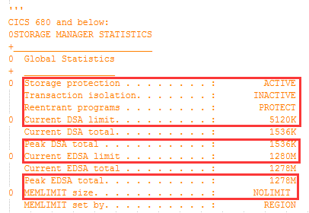

获得：STGPROT、TRANISO、REENTPG、DSALIM、PeakDSA、EDSALIM、PeakEDSA、MEMLIMIT
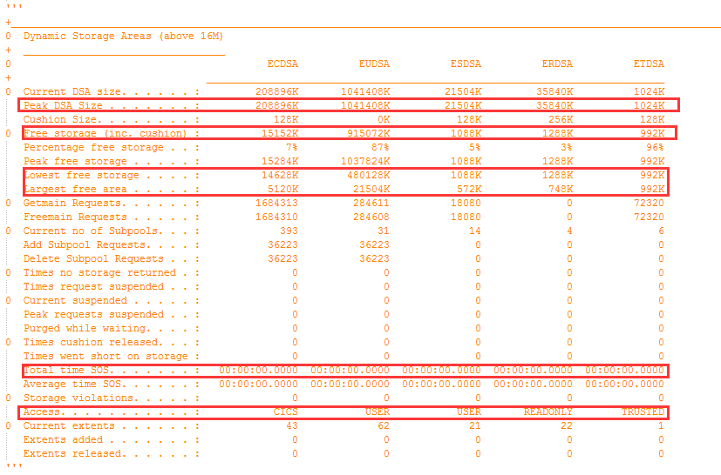
获得：C*、CFS*、CLFS*、CLFA*
以及CDSASOSTMS和CDSASTGVIOLTMS
*SIZE = C*
*HWM = C*-CLFS*
DSAHWMTotal = CDSAHWM+UDSAHWM+SDSAHWM+RDSAHWM
DSAHWMRatio = DSAHWMTotal/DSALIM
DSASOTms = CDSASOSTMS
DSASTGVIOLTms = CDSASTGVIOLTMS
*FragRatio = CFRAGRATIO*
(* = CDSA、UDSA、SDSA、RDSA)
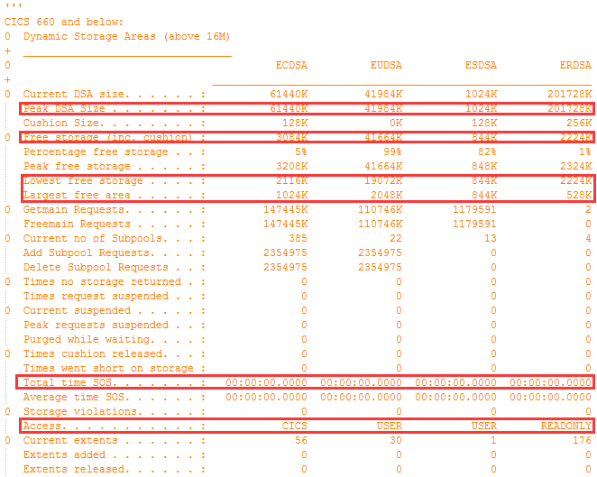
获得：CE*、CFSE*、CLFSE*、CLFAE*
以及CEDSASOSTMS和CEDSASTGVIOLTMS
E*SIZE = CE*
E*HWM = CE*-CLFSE*
EDSAHWMTotal = ECDSAHWM+EUDSAHWM+ESDSAHWM+ERDSAHWM
EDSAHWMRatio = EDSAHWMTotal/EDSALIM
EDSASOTms = ECDSASOSTMS
EDSASTGVIOLTms = ECDSASTGVIOLTMS
DSARatio = CPeakDSA/CDSALIM
EDSARatio = CPeakEDSA/CEDSALIM
*Ratio = C*/DSATotal
E*Ratio = EC*/EDSATotal
E*FragRatio = CFRAGRATIO*
(* = CDSA、UDSA、SDSA、RDSA)

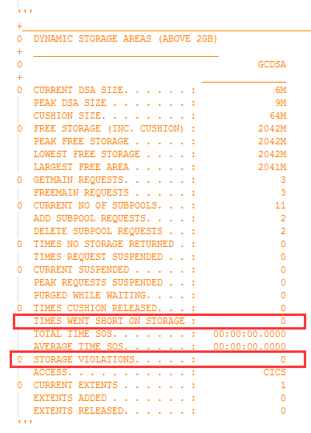
GDSASTGVIOLTms、CGDSASTGVOIL

10 StorageManagerReport
__Title = "Applid,Date,ResTime,ColTime,STGPROT,TRANISO,REENTPG,DSALIM,PeakDSA,EDSALIM,PeakEDSA,MEMLIMIT,CDSASize,UDSASize,SDSASize,RDSASize,ECDSASize,EUDSASize,ESDSASize,ERDSASize,ETDSASize,DSARatio%,EDSARatio%,CDSAHWM,UDSAHWM,SDSAHWM,RDSAHWM,DSASOSTms,DSASTGVIOLTms,ECDSAHWM,EUDSAHWM,ESDSAHWM,ERDSAHWM,ETDSAHWM,EDSASOSTms,EDSASTGVIOLTms, CDSAFragRatio%, UDSAFragRatio%, SDSAFragRatio%, RDSAFragRatio%, ECDSAFragRatio%, EUDSAFragRatio%, ESDSAFragRatio%, ERDSAFragRatio%, DSAHWMRatio%, EDSAHWMRatio%,GDSASOSTms, GDSASTGVIOLTms"

ItemList = list()

def __init__(self)
def AppendItem(self, SMItem)
def PrintInCSV(self)
def DumpToFile(self)

11 LogManagerItem
__CSVString = ''
Applid = '' #CICS Application ID
Date = '' #Data collection data
ResTime = '' #Last rest time
ColTime = '' #Data collection time
DFHLOG = '' #Name of DFHLOG
DASDOnly = '' #DSAD Only?
AKPFREQ = 0 #AKPFREQ setting
AKPTaken = 0 #AKP number
LGDFINT = 0 #LGDFINT setting
WriteReq = 0 #Write request number
ByteWritten = 0 #Bytes written
BufAppend = 0 #Buffer append times
WaitFullBuf = 0 #Times to wait due to buffer full
PkForceWts = 0 #The peak number of tasks suspended while requesting a flush of the logstream buffer currently in use
RetryError = 0 #MVS system logger retryable errors occurred when a block of data was being written to the logstream
ShuntWriteRequest = 0 #Write request against DFHSHUNT

def LogManagerItemCSV(self)

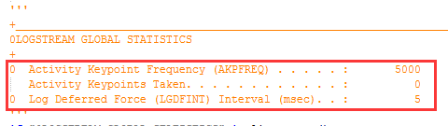

获得：AKPFRQE、AKPTaken、LGDFINT
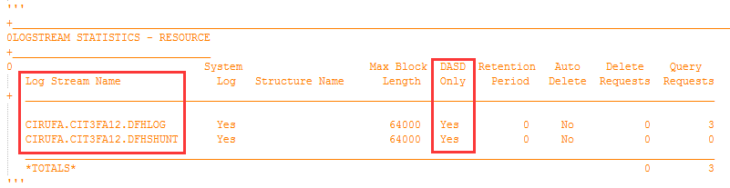
获得：DFHLOG、DASDOnly
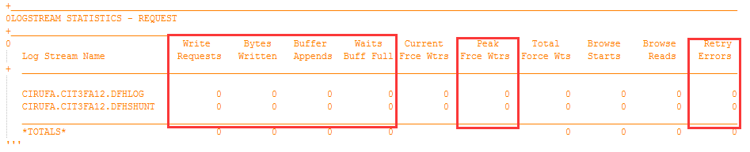
获得： WriteReq、ByteWritten、BufAppend、WaitFullBuf、PkForceWts、

ShuntWriteRequest(index+7)

12 LogManagerReport
__Title = "Applid,Date,ResTime,ColTime,DFHLOG,DASDOnly,AKPFREQ,AKPTaken,LGDFINT,WriteReq,ByteWritten,BufAppend,WaitFullBuf,PkForceWts,RetryError,ShuntWriteRequest"

LGItemList = list()

def __init__(self)
def AppendItem(self, LGItem)
def PrintInCSV(self)
def DumpToFile(self)

13 DB2ENTRYItem
__CSVString = ''
Applid = '' #CICS Application ID
Date = '' #Data collection data
ResTime = '' #Last rest time
ColTime = '' #Data collection time
DB2EntryName = '' #DBEntry name
AccountRec = '' #Accounting record
ThreadWait = '' #Thread wait
ThreadPrty = '' #Thread priority
CallCount = 0 #Numbers of SQL call
SignonCount = 0 #Numbers of Signon
PartialSignon = 0 #Numbers of Partial singons
TwoPCommitCount = 0 #2PC count
AbortCount = 0 #Abort count
OnePCommitCount = 0 #1PC count
ThreadCreate = 0 #Number of create thread requests
ThreadReuse = 0 #Times to reuse a thread
ThreadTerms = 0 #Number of terminate thread requests
ThreadWtOrOF = 0 #Times all threads were busy and a transaction had to wait for a thread to become available, or overflow to the pool
ThreadLimit = 0 #Thread Limit for this DB2ENTRY
ThreadHWM = 0 #Peak active threads
PthreadLimit = 0 #Protected thread limit
PthreadHWM = 0 #Peak active protected threads
Readyq = 0 #Peak number of CICS tasks that waited for a thread to become available on this DB2ENTRY
Reuselm = 0 #Times the reuselimit has been reached by a thread for this DB2ENTRY
CommitRatio = 0.0 #Percentage of success commit
ThreadRatio = 0.0 #Percentage of thread limit usage
PthreadRatio = 0.0 #Percentage of pthread usage

def DB2ENTRYItemCSV(self)
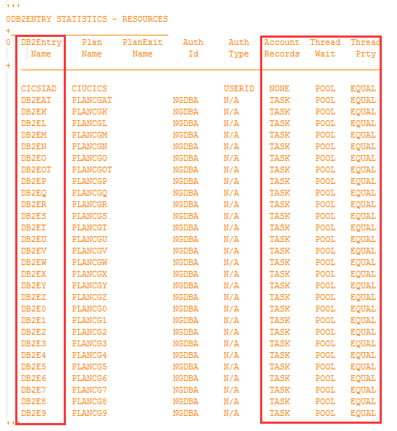
获得：DB2EntryName、AccountRec、ThreadWait、ThreadPrty
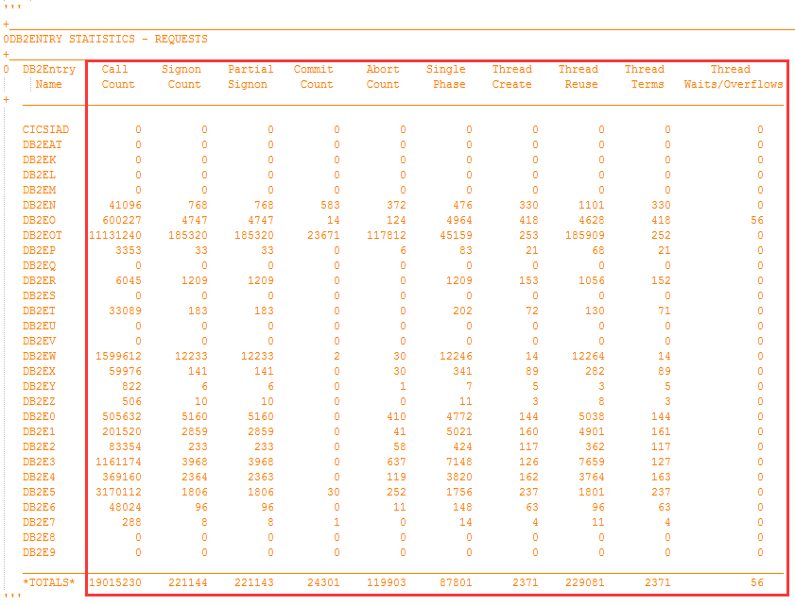
获得：CallCount、SignonCount、PartialSignon、TwoPCommitCount、AbortCount、OnePCommitCount、ThreadCreate、ThreadReuse、ThreadTerms、ThreadWtOrOF
CommitRatio = (TwoPCommitCount+OnePCommitCount)/(TwoPCommitCount+OnePCommitCount+AbortCount)

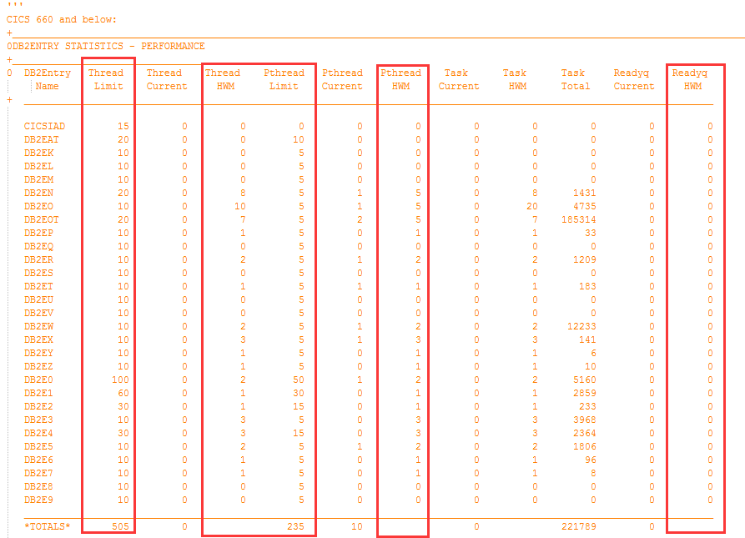
获得ThreadLimit、ThreadHWM、PthreadLimit、PthreadHWM、Readyq、Reuselm

ThreadRatio = ThreadHWM/ThreadLimit
PthreadRatio = PthreadHWM/PthreadLimit

14 DB2CONNItem
__CSVString = ''
Applid = '' #CICS Application ID
Date = '' #Data collection data
ResTime = '' #Last rest time
ColTime = '' #Data collection time
DB2Conn = '' #DB2CONN name
TCBLimit = 0 #TCBLIMIT
PkConnWithTCB = 0 #Peak Connection
PkConnReadyq = 0 #Peak number of tasks on the Conn Readyq
PoolPriority = '' #Priority of the pool thread
PkPoolTasks = 0 #Peak number of Pool Threads in use
PkPoolReadyq = 0 #Peak number of tasks on the Pool Readyq
PkCmdThreads = 0 #Peak number of Command Threads
DB2TCBRatio = 0.0 #Percentage of TCBLIMIT usage
DB2ENTRYItemList = list()

def __init__(self)
def AppendDB2Entry(self,DB2ENTRYItem)
def PeakDEItem(self)
def DB2CONNItemCSV(self)
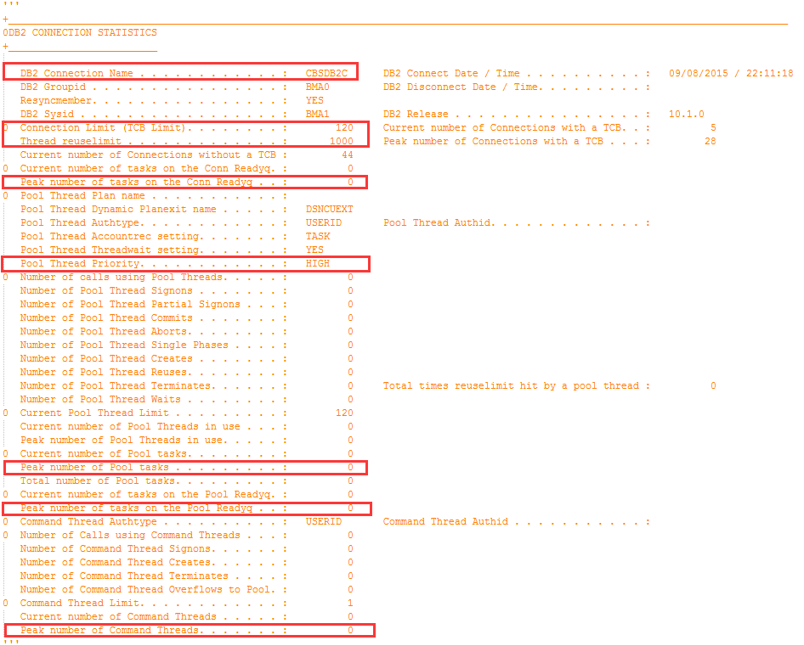
获得：DB2Conn、TCBLimit、PkConnWithTCB、PkConnReadyq、PoolPriority、PkPoolTasks、PkPoolReadyq、PkCmdThreads
DB2TCBRatio = CPkConnWithTCB/CTCBLimit

15 DB2Report
__Title_DC = "Applid,Date,ResTime,ColTime,DB2Conn,TCBLimit,PkConnWithTCB,PkConnReadyq,PoolPriority,PkPoolTasks,PkPoolReadyq,PkCmdThreads,DB2TCBRatio%"
__Title_DE = "Applid,Date,ResTime,ColTime,DB2EntryName,AccountRec,ThreadWait,ThreadPrty,CallCount,TwoPCommitCount,AbortCount,OnePCommitCount,ThreadCreate,ThreadReuse,ThreadTerms,ThreadLimit,ThreadHWM,PthreadLimit,PthreadHWM,Readyq,Reuselm,CommitRatio%,ThreadRatio%,PthreadRatio%"

DB2CONNItemList = list()

def __init__(self)
def AppendItem(self, DB2CONNItem)
def PrintInCSV(self)
def DumpToFile(self)

16 DumpItem
__CSVString = ''
Applid = '' #CICS Application ID
Date = '' #Data collection data
ResTime = '' #Last rest time
ColTime = '' #Data collection time
SysDumpTaken = 0 #System dumps taken
SysDumpSupp = 0 #System dumps suppressed
TranDumpTaken = 0 #Transaction dump taken
TranDumpSupp = 0 #Transaction dump suppressed

def DumpItemCSV(self)
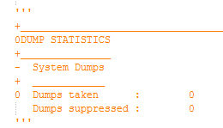

获得SysDumpTaken、SysDumpSupp

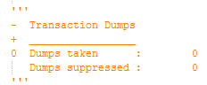
获得TranDumpTaken、TranDumpSupp

17 DumpReport
__Title = "Applid,Date,ResTime,ColTime,SysDumpTaken,SysDumpSupp,TranDumpTaken,TranDumpSupp"

DumpItemList = list()

def __init__(self)
def AppendItem(self, DumpItem)
def PrintInCSV(self)
def DumpToFile(self)

18 TSQItem
__CSVString = ''
Applid = '' #CICS Application ID
Date = '' #Data collection data
ResTime = '' #Last rest time
ColTime = '' #Data collection time
PutqMainReqs = 0 #Put main TSQ requests
GetqMainReqs = 0 #Get main TSQ requests
TSMAINLIMIT = 0 #Main stroage limit for TSQ
TSMAINLIMITTms = 0 #Times to reach TSQ storage limit
PeakUsedTSMAIN = 0 #Storage used
TSMAINLIMITRatio = 0.0 #Percentage of TSMAINLIMIT usaged
AutoDelTSQs = 0 #Number of TS queues auto-deleted
PutqAuxReqs = 0 #Put/Putq auxiliary storage requests
GetqAuxReqs = 0 #Get/Getq auxiliary storage requests
QueueCreTms = 0 #Times queues created
CISize = 0 #Control Interval size
WriteMTCI = 0 #Writes more than control interval
LongestRec = 0 #Longest auxiliary temp storage record
AuxStgExh = 0 #Times aux. storage exhausted
TSCompress = 0 #Number of temp storage compressions
BufferWait = 0 #Buffer waits
StringWait = 0 #String wait
IOErrorTSQDS = 0 #IO error on TS dataset
GetqShareReqs = 0 #Shared read requests
PutqShareReqs = 0 #Shared write requests

def TSQItemCSV(self)
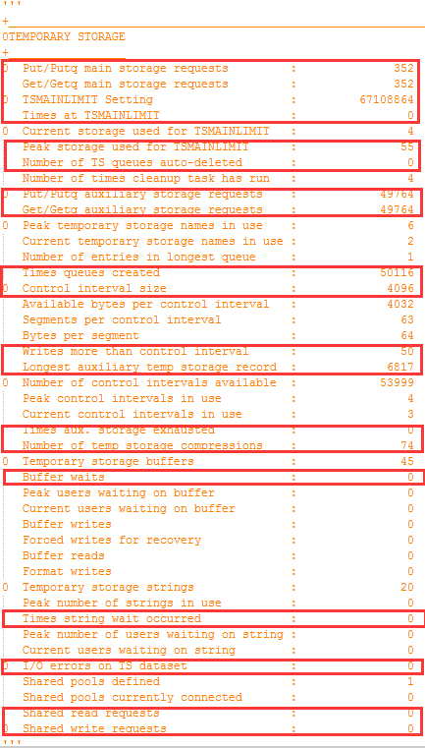
获得：PutqMainReqs、GetqMainReqs、TSMAINLIMIT、TSMAINLIMITTms、PeakUsedTSMAIN、AutoDelTSQs、PutqAuxReqs、GetqAuxReqs、QueueCreTms、CISize、WriteMTCI、LongestRec、AuxStgExh、TSCompress、BufferWait、StringWait、IOErrrorTSQDS、GetqShareReqs、PutqShareReqs

TSMAINLIMItRatio = PeakUsedTSMAIN/TSMAINLIMIT

19 TSQReport
__Title = "Applid,Date,ResTime,ColTime,PutqMainReqs,GetqMainReqs,TSMAINLIMIT,TSMAINLIMITTms,PeakUsedTSMAIN,TSMAINLIMITRatio%,AutoDelTSQs,PutqAuxReqs,GetqAuxReqs,QueueCreTms,CISize,WriteMTCI,LongestRec,AuxStgExh,TSCompress,BufferWait,StringWait,IOErrorTSQDS,GetqShareReqs,PutqShareReqs"

TSQItemList = list()

def __init__(self)
def AppendItem(self, TSQItem)
def PrintInCSV(self)
def DumpToFile(self)

20 TDQItem
__CSVString = ''
Applid = '' #CICS Application ID
Date = '' #Data collection data
ResTime = '' #Last rest time
ColTime = '' #Data collection time
PutqIntraReqs = 0 #Writes to intrapartition dataset
GetqIntraReqs = 0 #Reads from intrapartition dataset
IOErrors = 0 #I/O errors
BufferWait = 0 #Intrapartition buffer waits
StringWait = 0 #String waits
NOSPACETms = 0 #NOSPACE condition
IntraBuffers = 0 #Intra buffers
PeakIntraBuffData = 0 #Peak valid
StringNum = 0 #String number

def TDQItemCSV(self)

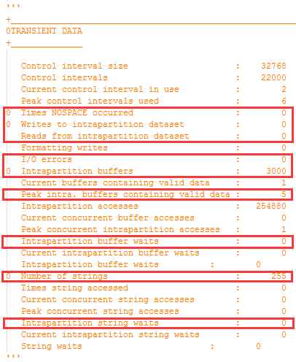
获得：NOSPACETms、PutqIntraReqs、GetqIntraReqs、IOErrors、IntraBuffers、PeakIntraBufferData、BufferWait、StringNum、StringWait

21 TDQReport

__Title = "Applid,Date,ResTime,ColTime,NOSPACETms,PutqIntraReqs,GetqIntraReqs,IntraBuffers,PeakIntraBuffData,BufferWait,StringNum,StringWait"

TDQItemList = list()

def __init__(self)
def AppendItem(self, TDQItem)
def PrintInCSV(self)
def DumpToFile(self)

22 ConnectionItem
Applid = '' #CICS Application ID
Date = '' #Data collection data
ResTime = '' #Last rest time
ColTime = '' #Data collection time
TotalAlloc = 0 #TOTAL NUMBER OF ALLOCATES
QueuedAlloc = 0 #QUEUED ALLOCATES
FailedLinkAlloc = 0 #FAILED LINK ALLOCATES
FailedAllocSessUsed = 0 #FAILED ALLOCATES DUE TO SESSIONS IN USE

def ConnectionCSV(self)

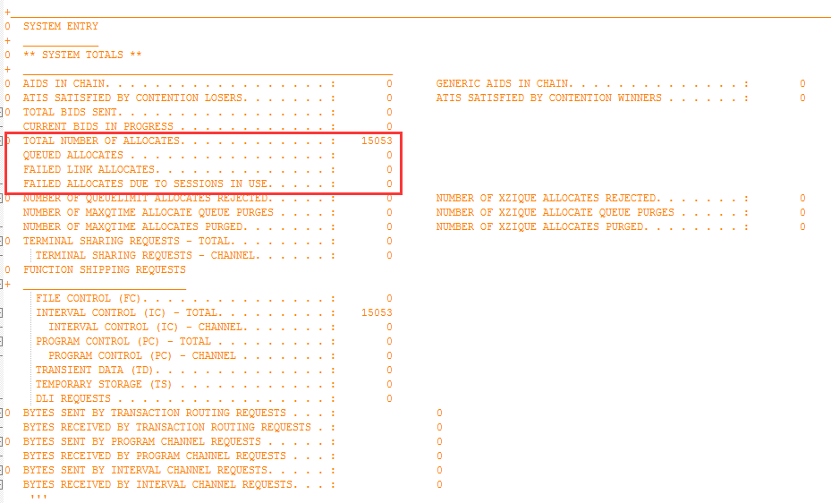
获得：TotalAlloc、QueuedAlloc、FailedLinkAlloc、FailedAllocSessUsed

23 ConnectionReport
__Title = "Applid,Date,ResTime,ColTime,TotalAlloc,QueuedAlloc,FailedLinkAlloc,FailedAllocSessUsed"

CONItemList = list()

def __init__(self)
def AppendItem(self, CONItem)
def PrintInCSV(self)
def DumpToFile(self)

24 IntervalItem
__CSVString = ''
Applid = '' #CICS Application ID
Date = '' #Data collection data
ResTime = '' #Last rest time
ColTime = '' #Data collection time
TMItem = TransactionManagerItem()
DSItem = DispatcherItem()
NQItem = EnqueueItem()
SMItem = StorageManagerItem()
LGItem = LogManagerItem()
DCItem = DB2CONNItem()
DUItem = DumpItem()
TSQItem = TSQItem()
TDQItem = TDQItem()
CONItem = ConnectionItem()

def __init__(self)
def UpdateIntervalInfo(self) 更新10个Item的4个基本信息
def IntervalFullJSON(self)
def IntervalBriefJSON(self)

获得：APPLID、CollectDate、CollectTime、LastResetTime、IntervalV

ReportType 0:INTERVAL ERPORT
1:END OF DAY STATISTICS REPORT
2:REQUESTED STATISTICS REPORT

if(APPLID不符合正则) 跳过
if(APPLID不同||ResetTime不同)
if(APPID空&&ResTIme空) 填充当前IntItem else 新建IntItem

25 IntervalItemListByInterval
ResTimeMin = '' #Last rest time in minutes, remove second because second may be different for applids
ColTimeMin = '' #Data collection time in minutes, remove second because second may be different for applids
ItemList = list()
TotTranNum = 0

ScoreTransaction = 100
RiskTransaction = ''

ScoreDispatch = 100
RiskDispatch = ''

ScoreStorage = 100
RiskStorage = ''

ScoreData = 100
RiskData = ''

ScoreQueue = 100
RiskQueue = ''

ScoreOther = 100
RiskOther = ''

global DSARATIOTHRES
global EDSARATIOTHRES
global QRDISPRATIOTHRES
global ENQIMMESUCCESSTHRESHOLD
global TMFlag
global TCFlag
global DSFlag
global LGFlag
global DBFlag
global NQFlag
global TSQFlag
global TDQFlag
global SMFlag
global CONFlag
global DUFlag

def __init__(self)
def AppendItem(self,IntervalItem)
def InsightsTM(self)
def InsightsTC(self)
def InsightsDS(self)
def InsightsSM(self)
def InsightsLG(self)
def InsightsDB(self)
def InsightsNQ(self)
def InsightsTSQ(self)
def InsightsTDQ(self)
def InsightsCON(self)
def InsightsDU(self)
def InsightsRiskSummary(self)
def IntervalScoreJSON(self)
def HealthSummary(self)

26 IntervalReport
IntervalItemList = list()
SubListbyInterval = list()
ApplidSet = set()
ApplidNum = 0
IntervalSet = set()
IntervalNum = 0
PeakColTime = ''
PeakTotalTran = 0
PeakIndex = -1
ExtractFlag = 0

def __init__(self)
def AppendItem(self,IntItem)
def ExtractInfo(self)
def SummInfoJSON(self)
def TrendInfoJSON(self)
def PeakInfoJSON(self)
def PeakScoreJSON(self)
def InsightsTMPeak(self)
def InsightsDSPeak(self)
def InsightsSMPeak(self)
def InsightsTCPeak(self)
def InsightsLGPeak(self)
def InsightsDBPeak(self)
def InsightsNQPeak(self)
def InsightsTSQPeak(self)
def InsightsTDQPeak(self)
def InsightsCONPeak(self)
def InsightsDUPeak(self)
def InsightsScorePeak(self)
def InsightsAllInterval(self)

